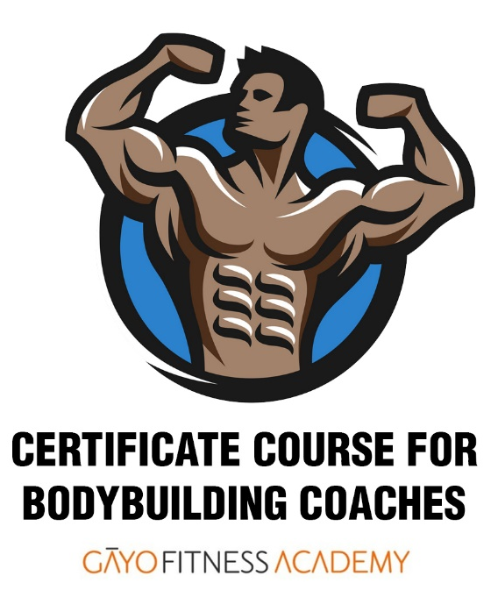
CERTIFICATE COURSE FOR BODY BUILDING COACHING (CCBBC)
India’s only SPECIALIST course for Bodybuilding Coaches!
- Gāyo Fitness Academy certification co-signed by
International Faculty
- CCBBC teaches –
  - Anatomy & Physiology & Kinesiology & Biomechanics
  - Weight Training & Olympic Lifting for Bodybuilding
  - Plyometrics & Functional Strength Training
  - Periodization – training cycles: off-season, pre
season, in-season
  - Diet and Nutrition * Supplementation
  - Steroids – Physiology – Medical & Psychological Effects\
of steroids on performance, personality – WADA/NADA
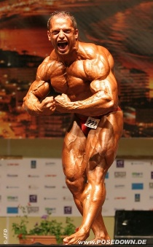
regulations
  - Posing & Flexing
    - Music Cueing & Choreography
  - Women’s issues in Bodybuilding & Physique Contests
  - Training considerations for Men and Women for –
    - Bodybuilding
    - Physique
    - Figure & Bikini contests
- Faculty includes –
  - Bernat Scorus – From Hungary, now in Spain. Has conducted training & nutrition seminars in Europe. International bodybuilder in heavy / super heavy categories. He is renowned expert in bodybuilding nutrition.
  - Georgina D’Abreo – From Canada. Noted coach and IFBB pro card holder. Expert in posing.
  - Kim Marie Pauline – From USA. Noted coach judge and BB nutritionist
- Students get
  - 5 textbooks / Notes and 800 exercise videos
  - Free professional guidance after enrolment
- CCBBC FEE STRUCTURE
GFA certificate + 4 Workshop Certificates: ₹ 42,500 Basic Minimum Fee.
Optional:
[ ] NSQF LEVEL 4 CERT (SKILLS INDIA - SPEFL-SC) ₹ 4,500 OPTIONAL but ADVISABLE for Domestic Indian
market. Student registered in Govt of India’s National Skills Register. Includes 18% GST.
[ ] Other ₹ ______
Icludes GST

- Student Eligibility
  - Must have passed 10 + 2 years of Education
  - Must be physically and medically fit
  - Must have bodybuilding experience
  - Physically Challenged persons can apply if they have exposure to fitness / sport
  - Must be certified in First Aid & CPR with AED

- Examinations – TOTAL marks 500 – Minimum 50%
  - Home study assignment, case study, practical training exam (video recorded)
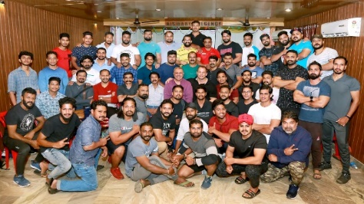
Our CCBBC batch in Thrissur – September – December 2019 batch!
- Summary of TERMS AND CONDITIONS
- For COURSE FEES payable see above. Student will pay GST as applicable
- The CCBBC Certificate is issued only those students who –
  - attend the full course with minimum of 50% attendance in each of the Guided Learning sections, and
  - pass the Course Exams with at least 50%.
- We strongly recommend that student enrols to Skills India National Skills Qualification Level 4 (NSQF L4) also known as Registration of Prior Learning (RPL) so that his / her name is entered in the Government of India’s National Skills Register.
- CCBBC Examination and Passing Grades awarded will be as follows. Examination system will be modified according to lockdown, social distancing, travel requirements. For example, ONLINE PROCTORED exams may replace in-person, classroom exams.
Theory Exam 100 Multiple Choice Questions. MAXIMUM MARKS 100
The subjects covered are: Anatomy, Physiology, Kinesiology, Principles of Diet & Nutrition Management.
Practical Home Study Assignment #2 MAXIMUM MARKS 100
Real-time (In-Classroom / webinars) Assessment. MAXIMUM MARKS 100
Student will be assessed for in-classroom interaction, proactive participation in class, punctuality, social skills, etc, on basis of OSCE principles.
End of Term Course
Theory Exam: 100 Multiple Choice Questions. MAXIMUM MARKS 100
The subjects covered will be –
- practical training workshops including the theory or "physiologies" underpinning them.
- Fitness Assessment & Exercise Periodization
f the viva voce exam.
Practical Training Exam - Peer Teaching Lesson. MAXIMUM MARKS 200
Each student will be assessed on basis of TWO exercise from the case study according to NASTY method of assessment
Viva Voce. MAXIMUM MARKS 100.
Oral questions will be asked about the exercise taught, related kinesiology and exercise prescription as mentioned in the Case Study submitted.
TOTAL Marks – 600 Passing Marks: at least 300 out of 6000.
Assessment Process
The examination system is in line with the process laid down by BPCACPE – University of Mumbai.
Theory Examinations
Multiple Choice Questions.
a. The questions will cover the entire syllabus to the extent possible.
b. Each correct answer shall be awarded 2 marks. Where a question entails two answers, each of the two will be awarded one mark each.
Practical Training Assessment
See above: “Practical Training Exam - Peer Teaching Lesson”
The Course Examination Results
These will be placed before the Academic committee. A copy of the documents is also submitted to BPCACPE – University of Mumbai.
Assessment Grades printed on CCBBC certificates: As percentage (%) of total marks obtained out of maximum 1,000 marks.
Below 49.99% - Grade D (FAIL) ● 50 - 54.99 - Grade C ● 55 - 59.99 - Grade B ● 60 - 69.99 - Grade A ● 70 - 100 - Grade O (Outstanding)
Students with Grades C, B, A and O will be declared FIT To WORK AS PERSONAL TRAINER.
Students with Grade D will have to reappear for exams in which they have earned less than 50%. The first re-exam fee will be @ ₹500 per exam. Second re-exam fee will be @ ₹1,000 per exam.
- Student may appeal against the Grade awarded as per prescribed procedure and payment of appeal fee ₹5,000. Conditions apply.
- Faculty / dates and timings of lectures / webinars and workshops may change due to reasons beyond our control.
- CCBBC CERTIFICATE IS NOT RENEWABLE. During each three years period, student must attend 30 hours (CEUs) of additional training.
- Please visit www.gayofitnessacademy.com for CEUs workshops and applicable fees.
- Skills India NSQF / RPL certification is awarded subject to additional examination.
- Please see Terms & Conditions of Enrolment.
- Please visit www.gayofitnessacademy.com for full CCBBC syllabus.
- We will revert to full classroom teaching as soon as lockdown, social distancing and travel restrictions permit. No additional fees will be payable for classroom delivery
- Terms & Conditions / Rules & Regulations and Fees are subject to change without prior notice and will be applicable to student as on current date – not as on date of earlier enrolment, if any.

Call us on for information and enrolment process!
MUMBAI: GĀYO FITNESS ACADEMY NATIONAL Admin Office: +91 81048 39793
info@gayofitnessacademy.com
● Andhra Pradesh / Telangana: Usha Sri +91 96180 69357 (Hyderabad) ● Assam & N. E. India: Angshuman Dutta +91 99540 85215 (Guwahati) ● Chhattishgarh / M. P.: Neha Wadhwa +91 95222 20188 (Raipur) ● Goa: Shania Coutonho +91 96990 78033 (Margaon) ● Gujarat: Mona Patel +91 95582 61233 (Ahmedabad) ● Karnataka: Gururaj S. P. +91 90367 17970 (Bengaluru) / Priya Ijeri +91 72048 24600 (Vijayapur) ● Kerala: Arya CS +91 90744 82180 (Kollam) ● New Delhi / NCR /Punjab: Vaishali +91 96507 84966 ● Maharashtra: Rollen Frantz +91 97309 84048 (Pune) ● Tamil Nadu & Puducherry: Gopal Pandiyan +91 9894377327 (Chennai) ● West Bengal: Bibasha Pal +91 98311 13444 (Kolkata)

