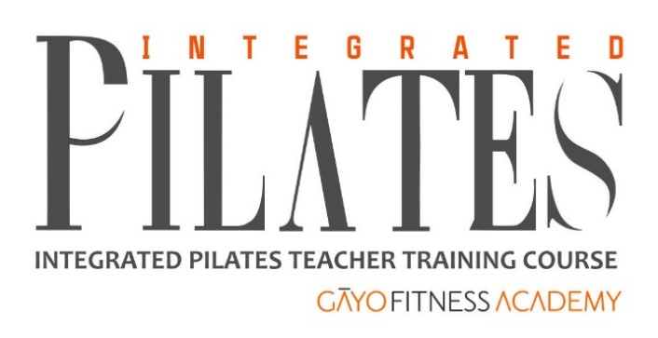

OVERVIEW
Certificate Course for Integrated Pilates Teachers – CCIPT

Gāyo’s Certificate Course for Integrated Pilates Teachers is India’s first formally structured Pilates Teacher Training program. In 2008, Gāyo introduced Pilates Institute of America’s (PIA) Pilates Teacher training programs.

Our CCIPT is accredited internationally by Europe Active EREPs as Level 4 Pilates Trainer course.

Student Eligibility
- Must have minimum education qualification of 10 + 2
- Preferred: prior certification / qualification in Fitness & Exercise Sciences
- For Pilates on Reformer, prior certification in modules in Pilates on Mat and Ball is required.
- Integrated Pilates Teacher certificate is issued to students who successfully complete all modules.

Course Outline
CCIPT comprises Modules in Exercise Sciences and Pilates on Mat, Ball and Reformer. It is structured with due consideration to the following principles.
- Each Pilates student will receive in Theory & Practice, to the extent possible, the fullest information relating to history and philosophy of Joseph Pilates and his “Body Contrology”
- Each academic module (“Module”) logically leads the student to the next higher “Module”.
- A student can get certified in the individual Modules or gather all the Modules and become a certified Integrated Pilates Teacher.
- Student evaluation is based on assessment of theory, practical training and delivery of knowledge to clients.
- Develop a competent Pilates teacher recognized and respected internationally.

Visit www.gayofitnessacademy.com/CCIPT for more detailed syllabus
Zarana – please give correct URL here

THE CCIPT COMPRISES THREE INDEPENDENT MODULES:

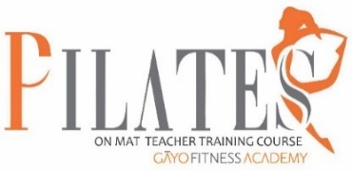
Module A – Pilates on Mat
Duration: Total 155 hours of BLENDED training
- 40 hours online sessions
- 15 hours of in-person training
- 100 hours of Guided Home Study

Fee: ₹25,000 + 18% GST

Course syllabus
- Profile & Philosophy of Joseph Pilates
- About 145 exercises on Mat
- Guided Home Study
- Home Assignments – you have to practice and send us video recording of certain number of exercises
- Theory & Practical Assessment – your home assignments will also be assessed,

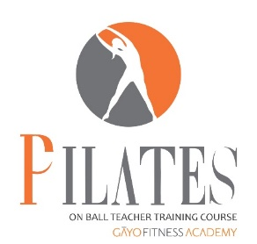
Module B – Pilates on the Ball

Duration: Total 100 hours of BLENDED training
- 30 hours online sessions
- 10 hours of in-person training 60 hours of Guided Home Study

Fee: ₹15,000 + 18% GST

Course syllabus
- About 65 exercises on Ball
- Guided Home Study
- Home Assignments
- Assessment
- Certification
Module C – Pilates Reformer
Duration: Total 200 hours of BLENDED training
- 20 hours online sessions
- 60 hours of in-person training
- 120 hours of Guided Home Study

Fee: ₹30,000 + 18% GST

Course syllabus
- Introduction to Reformer
- Setting and Safety issues re: Reformer
- About 100 exercises on Reformer

Module 2: Theory – fee is included in Module 1A – Pilates on Mat course
Must be completed before Pilates on Reformer course.
Duration: 30 hours

Module 2A – Introduction to Exercise Physiology: Introduction to Exercise Physiology: Anatomy & Physiology, Energy Systems, Training Effects and Homeostasis, Muscle Structure and Muscle Contraction Mechanism, Muscle Fibres, etc.

Module 2B – Theory & Practice of Kinesiology & Biomechanics: Theory & Practice of Kinesiology & Biomechanics: Planes and Axes of Movements. Structure of Joints and Connective Tissues, Types of Muscles – agonist, antagonist, etc, Movements about Joints and Muscles, Names, Types of Muscles and their role in Muscle Contraction, etc.

Module 2C – Theory & Practice of Fitness : 16 X 8 Matrix – 16 types of Fitness through permutation and combination of 8 general categories of training technologies

Above Modules 2A, 2B and 2C are part of our University of Mumbai’s Certificate Course for Personal Fitness Trainers – CCPFT. Pilates Mat students may like to attend the relevant classes in CCPFT. The fee for these three modules in not included in Pilates on Mat fee. Additional Fee is payable for these classes. Course credits are available to those who meet above-listed Student Eligibility requirements.

Module 3 – First Aid & CPR with AED – fee ₹2,500 + 18% GST
This course is exempted if student holds a current FACPR AED certificate.

If student does not hold FACPR AED certificate, our FACPR course may be attended. Student must have valid certificate before end of Pilates on Mat module.

CERTIFICATION
- Each of above 3 Pilates modules leads to certification subject to home assignments submission and passing assessment with minimum 50% and having current FACPR certificate.
- Completion of all 3 modules and First Aid CPR and AED Course leads to automatic grant of –
- Gāyo Fitness Academy’s Integrated Pilates Teacher Certificate.
- EREPS Level 4 Pilates Trainer certificate (renewable every year) subject to –
  - payment of extra fee for EREPS
  - mandatory examination and certificate from Skills India - National Skills Qualification (NSQF) Level 4.
- NSQF Level 4 is –
- Optional but HIGHLY RECOMMENDED even if you plan to work in India
- MANDATORY if you plan to work abroad for which purpose you will seek certification/s from the following
- First Aid & CPR with AED training and certification.

No Certification Renewal
- Gāyo Fitness Academy’s Pilates on Mat, Pilates on Ball and Pilates on Reformer and Integrated Pilates Teacher Certificates need not be renewed. They have no expiry date/s.
- However, it is recommended that our Pilates Teachers complete 30 hours of Continuing Education in every three years.
- EREPS renewal: The EREPS certificate needs to be renewed every year by paying renewal fee.

Faculty
Ms Saima
Joseph Pilates: “Breathing is the first act of life and the last. Our very life depends on it.” To him, focusing on breathing was vital. “It is tragically deplorable,” he once said, “to contemplate the millions who have never mastered the art of correct breathing.” How apt in today’s COVID-19 times!

Saima trained with Frankie Puglisi, one of USA’s leading Pilates Teachers who worked closely with Lolita San Miguel – the only living teacher to have been trained by Joseph Pilates himself! So, when she teaches you, you can expect authentic Pilates being delivered to you. We brought authentic Pilates Teaching programs to India in 2009.

Connect with us – we will be delighted to help you launch a successful career as an Integrated Pilates Teacher!
Gāyo Fitness Academy (GFA) TERMS & CONDITIONS OF ENROLMENT to CCIPT
- Fees
  - Student will pay the fee for each module in full before the course commences.
  - He / she may be allowed to pay fee in equated monthly instalments (EMIs) or according to Module/s that he/she attends under specific conditions: (i) he/she will not be eligible to discounts, (ii) If he/she pays in EMIs, student will forfeit the fee amount paid if he/she is unable to complete the full and final payment within 15 days of the final examinations and his/her enrolment will stand cancelled..
  - NSQF LEVEL 4 CERTIFICATION (SPEFL-SC / SKILLS INDIA RPL), EREPS and further certification/s under proposed international accreditations are optional.
  - CCIPT modules’ Fees and fee/s of OPTIONAL CERTIFICATIONS are liable to change without prior notice due to circumstances beyond GFA’s control. Student will ascertain and accept the fee amount/s at the time of this enrolment
  - CCIPT fee may vary from state to state due to additional programs / workshops and / or translation services provided.
  - Payment must be made by NEFT / Google Pay or Phone Pe in favour of GĀYO FITNESS ACADEMY
  - Credit / Debit card payment must be made through secured payment gateway on www.gayofitnessacademy.com.
    - Card payment will entail additional transaction fee which will be reflected at time of online payment.
    - Delay in or decline of card payment for any reasons whatsoever will not be liability or responsibility of GFA.
    - Card payment is credited to our bank account within 6 working days after date of payment. Enrolment process will commence only after payment is credited to our account.
  - Extra fees may be payable for (i) late submission of enrolment documents, (ii) post-enrolment change in name / address / contact details, etc, (iii) late submission of assignments / examinations, (iv) re-shipping due to non-delivery of course related documents in first attempt, (v) appeals / revalidation of examination results,(vi) certificate renewal, (vii) other issues etc which are not included in CCIPT fee.
  - Taxes and course related costs may be additionally payable.
  - Delay or default in payment of fee will lead to cancellation of enrolment before commencement of course and, after commencement of course, the fee paid in part will be adjusted against number of course days / workshops attended.
  - Refund, if any, of fee, for any reason whatsoever, will be made only if enrolment is cancelled before course commencement and will attract deduction of administrative fee of ₹ 2,500 from amount refundable.
- Academics
  - Student strictly meets the pre-enrolment criteria including minimum education qualification of 10 + 2 and personal trainer course completion and certification or equivalent certificate.
  - Student agrees to abide by the rules relating to education & training, examination / assessment leading to certification for CCIPT modules.
  - As per CCIPT requirements, student will submit video recordings of assignments and undergo evaluations / examinations. Student agrees to and permit the said video recording/s and / or his/her personal and academic records to be shared with other academic bodies for only confidential academic purposes and not for commercial or public use or display.
  - Student accepts that CCIPT and other certificates will be awarded only upon successful completion of the training, assignments and examinations, minimum attendance and OSCE evaluation, according to academic standards published on www.gayofitnessacademy.com, provided I have paid the fee is paid in full.
  - Student agrees to renew, on my own at his/her own expense, EREPS / other related certifications and First Aid & CPR certificate as required.
  - Student will comply with the rules and regulations of BPCACPE / GFA / Accreditation bodies in connection with his/her CCIPT module/s as also comply with regulations of training centre / facility / premises where I will attend CCIPT training program /course failing which I alone will be responsible for loss of or damage to person / property in the said centre / facility / premises and neither GFA nor its officers nor teaching faculty will be held liable for the same.
- General
  - Student understands and accepts that during the CCIPT training, he/she may suffer from exercise-related or non-exercise related or other injury / accident. Student will have enrolled to the training program / course having convinced that GFA and its training faculty and training facility providers have exercised due diligence in ensuring a safe training program. Student will not hold them responsible in any manner for the injury to him/her or damage to his/her property.
  - Student authorizes GFA to receive / archive / courier / email his/her CCIPT module/s / EREPS / other certificate/s and learning resources, etc on his/her behalf and this will not be considered as breach of confidentiality.
- WAIVER.
  - Student solemnly affirms that he/she suffer from no medical condition or illness in body and mind.
  - In case of any medical or physical condition, student will submit herewith a medical doctor’s certificate confirming that he/she is fit to enrol to and participate in CCIPT training program/s without which he/she will not be enrolled to CCIPT.
  - WARRANTY DISCLAIMER: Student has referred to terms & conditions, specific warranties and disclaimers for and on each training program / course and related learning resources. The enrolment to and / or purchase of training programs / courses (videos, manual and attending the live training program) and possessing, using and / or allowing the use thereof indicates and confirms his/her acceptance of and agreement with these Terms and Conditions.
- In case of any issue not covered above, GFA’s decision will be final in the matter.

