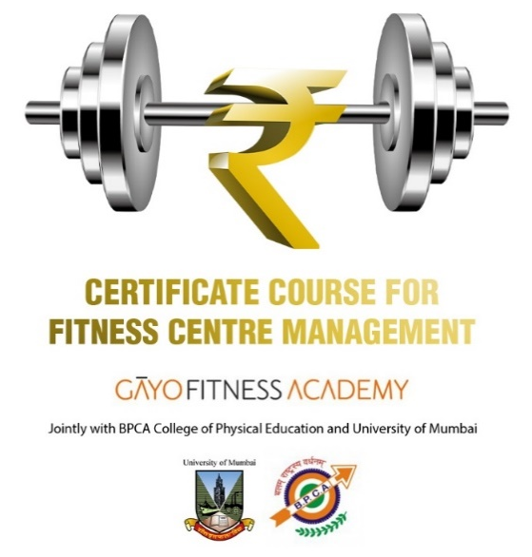
CCFCM 25112021

BLENDED
CERTIFICATE COURSE FOR FITNESS CENTER MANAGEMENT – CCFCM
Bringing Fitness and Business Together!

India’s only University course for fitness club & gym managers!

- Main certification by Mumbai U [Grade A - 5 Star NAAC ranking]
- Jointly conducted with BPCA's College of Phy Ed [NAAC grade "A" accredited (Mumbai U)]
- CCFCM teaches –
  - General Business Organization
  - Fitness Club Organization
  - Types of Clients Fitness Consumers
Skills India – SPEFL RPL / NSQF Level 4 exam & certificate is optional but HIGHLY RECOMMENDED.
Fee ₹4,000 extra

[Cite your source here.]
  - Client Psychology & Communication Skills
  - Types of Memberships
  - Marketing Principles
    - General
    - Fitness Club
    - Marketing & Branding
    - Marketing Media
    - Sales Conversion process
  - Operations –
    - Front Office
    - Back Office
      - Facility Maintenance
      - HR & recruitment
      - Basics of Book-keeping & Accounting
      - Taxation, Insurance
      - Legal Issues
      - Safety
      - Risk Management
  - Fitness Operations
    - Fitness Assessment & Exercise Prescription
    - Introduction to 16 X 8 Matrix
    - Introduction to Weight Training and other forms of exercise
    - Development of On-site and Off-site Revenues
  - Practical Training Courses
    - Fitness Assessment & Testing and Exercise Periodization
    - Exercise & Fitness Psychology
    - First Aid & CPR with AED
Students get
  - Text books
  - Exercise and Testing video clips
  - Free professional guidance after enrolment

- BLENDED Knowledge Delivery
  - Online webinars with PPTs and videos to offer face-to-face classroom experience
  - “IN-PERSON” Practical Training workshops subject to COVID19 situation
  - Home Assignments
  - Teaching in English and Hindi / where possible, in local state language

- Fee:
  - ₹27,500 incl GST
  - There are no discounts
  - Course credits will be awarded for the practical training workshops –
    - Fitness Assessment & Testing and Exercise Periodization
    - Exercise & Fitness Psychology
    - First Aid & CPR with AED

- Certifications:
  - University of Mumbai Certificate in Fitness Management
  - Fitness Assessment & Testing and Exercise Periodization
  - Exercise & Fitness Psychology
  - First Aid & CPR with AED

- Examinations – 600 Marks – Minimum passing 50%
  - Home study assignments
  - Theory examination
  - Case study presentation

- Student Eligibility
- Must have passed 10 + 2 years of high school education
- Must be physically and medically fit
- Must have passion for fitness / sport
- Physically Challenged persons can apply if they have exposure to fitness / sport
- Must have at least 3 years’ experience in personal and fitness training / sports
- BEFORE EXAMINATION, must attend and be certified in First Aid & CPR with AED

- Summary of TERMS AND CONDITIONS
- For COURSE FEE payable see above. Student will pay GST as applicable
- The CCFCM Certificate is issued by University of Mumbai to only those students who –
  - attend the full course with minimum of 50% attendance in each of the Guided Learning sections, and
  - pass the Course Exams with at least 50%.
- We strongly recommend that student enrols to Skills India National Skills Qualification Level 4 (NSQF L4) also known as Registration of Prior Learning (RPL) so that his / her name is entered in the Government of India’s National Skills Register.
- CCFCM Examination and Passing Grades awarded will be as follows. Examination system will be modified according to lockdown, social distancing, travel requirements. For example, ONLINE PROCTORED exams may replace in-person, classroom exams.
Practical Home Study Assignment MAXIMUM MARKS 200
Real-time (In-Classroom / webinars) Assessment. MAXIMUM MARKS 100
Student will be assessed for in-classroom interaction, proactive participation in class, punctuality, social skills, etc, on basis of OSCE principles.
End of Term Course
Theory Exam: 100 Multiple Choice Questions. MAXIMUM MARKS 200
The subjects covered will be –
- practical training workshops including the theory or "physiologies" underpinning them.
- Fitness Assessment & Exercise Periodization
Case Study presentation & Viva Voce: MAXIMUM MARKS 100
Student has to select only one out of three case studies and submit it at time of the viva voce exam.
TOTAL Marks – 600 Passing Marks: at least 300 out of 6,000.
Assessment Process
The examination system is in line with the process laid down by BPCACPE – University of Mumbai.
Theory Examinations
A) Multiple Choice Questions.
a. The questions will cover the entire syllabus to the extent possible.
b. Each correct answer shall be awarded 2 marks. Where a question entails two answers, each of the two will be awarded one mark each.
B) Case Study
The focus will be on how the student applies Exercise Sciences in a “real” situation. He / she will be marked for –
a. Introduction and outline of business and legal aspects of client training
b. Identification of Client’s Fitness Goals
c. Exercise periodization / program development, an eye on safety issues
d. Macrocycle, mesocycles and microcycles of training
e. Nutrition advice
The Course Examination Results
These will be placed before the Academic committee. A copy of the documents is also submitted to BPCACPE – University of Mumbai.
Assessment Grades printed on CCFCM certificates – University of Mumbai. As percentage (%) of total marks obtained out of maximum 1,000 marks.
Below 49.99% - Grade D (FAIL) ● 50 - 54.99 - Grade C ● 55 - 59.99 - Grade B ● 60 - 69.99 - Grade A ● 70 - 100 - Grade O (Outstanding)
Students with Grades C, B, A and O will be declared FIT To WORK AS PERSONAL TRAINER.
Students with Grade D will have to reappear for exams in which they have earned less than 50%. The first re-exam fee will be @ ₹500 per exam. Second re-exam fee will be @ ₹1,000 per exam.
- Student may appeal against the Grade awarded as per prescribed procedure and payment of appeal fee ₹5,000. Conditions apply.
- Faculty / dates and timings of lectures / webinars and workshops may change due to reasons beyond our control.
- CCFCM CERTIFICATE IS NOT RENEWABLE. During each three years period, student must attend 30 hours (CEUs) of additional training.
- Please visit www.gayofitnessacademy.com for CEUs workshops and applicable fees.
- Skills India NSQF / RPL certification is awarded subject to additional examination.
- Please see Terms & Conditions of Enrolment.
- Please visit www.gayofitnessacademy.com for full CCFCM syllabus.
- We will revert to full classroom teaching as soon as lockdown, social distancing and travel restrictions permit. No additional fees will be payable for classroom delivery
- Terms & Conditions / Rules & Regulations and Fees are subject to change without prior notice and will be applicable to student as on current date – not as on date of earlier enrolment, if any.

Call us on for information and enrolment process!
MUMBAI: GĀYO FITNESS ACADEMY NATIONAL Admin Office: +91 81048 39793
info@gayofitnessacademy.com
● Andhra Pradesh / Telangana: Usha Sri +91 96180 69357 (Hyderabad) ● Assam & N. E. India: Angshuman Dutta +91 99540 85215 (Guwahati) ● Chhattishgarh / M. P.: Neha Wadhwa +91 95222 20188 (Raipur) ● Goa: Shania Coutonho +91 96990 78033 (Margaon) ● Gujarat: Mona Patel +91 95582 61233 (Ahmedabad) ● Karnataka: Gururaj S. P. +91 90367 17970 (Bengaluru) / Priya Ijeri +91 72048 24600 (Vijayapur) ● Kerala: Arya CS +91 90744 82180 (Kollam) ● New Delhi / NCR /Punjab: Vaishali +91 96507 84966 ● Maharashtra: Rollen Frantz +91 97309 84048 (Pune) ● Tamil Nadu & Puducherry: Gopal Pandiyan +91 9894377327 (Chennai) ● West Bengal: Bibasha Pal +91 98311 13444 (Kolkata)

