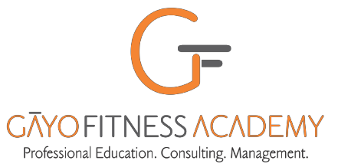

[GFA CCFCM ENROL 25112021]

Date: _______________
BLENDED CCFCM ENROLMENT FORM

I, ________________________________________________________________ have studied the BLENDED CCFCM COURSE OVERVIEW and agree voluntarily and unconditionally to the Terms & Conditions therein.

CCFCM FEE STRUCTURE
CERTIFICATE FEE Remarks
.
Mumbai U CCFCM + Workshop Certificates: ₹ 27,500 Includes relevant textbooks and online access to exercise video
and Mumbai University CCFCM certificate and certificates for practical training workshops: Advanced Strength Training – Level 1, Fitness Assessment & Testing and, Exercise Periodization, Exercise & Fitness Psychology, First Aid & CPR with AED

NSQF LEVEL 4 CERT (SKILLS INDIA - SPEFL-SC) ₹ 4,500 RECOMMENDED for Domestic Indian market. Student name is
registered in Govt of India’s National Skills Register. Mandatory for EREPs Level 4. NSQF Certificate issued on basis of MCQ test on smart phone.

NOTE: (a) Fee structure for and certification of CCFCM / NSQF may change without prior notice. Student will pay fee and comply with rules as prevailing on date of payment.

I have paid the fee/s* by –
[ ] NEFT transaction # ___________________
[ ] Credit / Debit Card payment thru www.gayofitnessacademy.com* Order Ref # _____________ dated _________
[ ] Google Pay transaction # _____________
under terms and conditions of enrolment on page2 which I unconditionally accept. *Additional gateway fee charged for payment via www.gayofitnessacademy.com

I upload proof of payment [ ]

Signature: ________________________

Name in CAPITAL letters – as per legal documents, please. Certificates will be issued in this name:

Postal Address: ________________________________________________________________________
________________________________________________________________________
________________________________________ PIN

Telephone Nos.: Landline: __________________________ Mobile: _______

EMAIL ADDRESS: ____________________________________________________________________

